**EXPLORATORY DATA ANALYSIS**

1. **EFFECT OF PRESSURE ON RIDE USAGE**

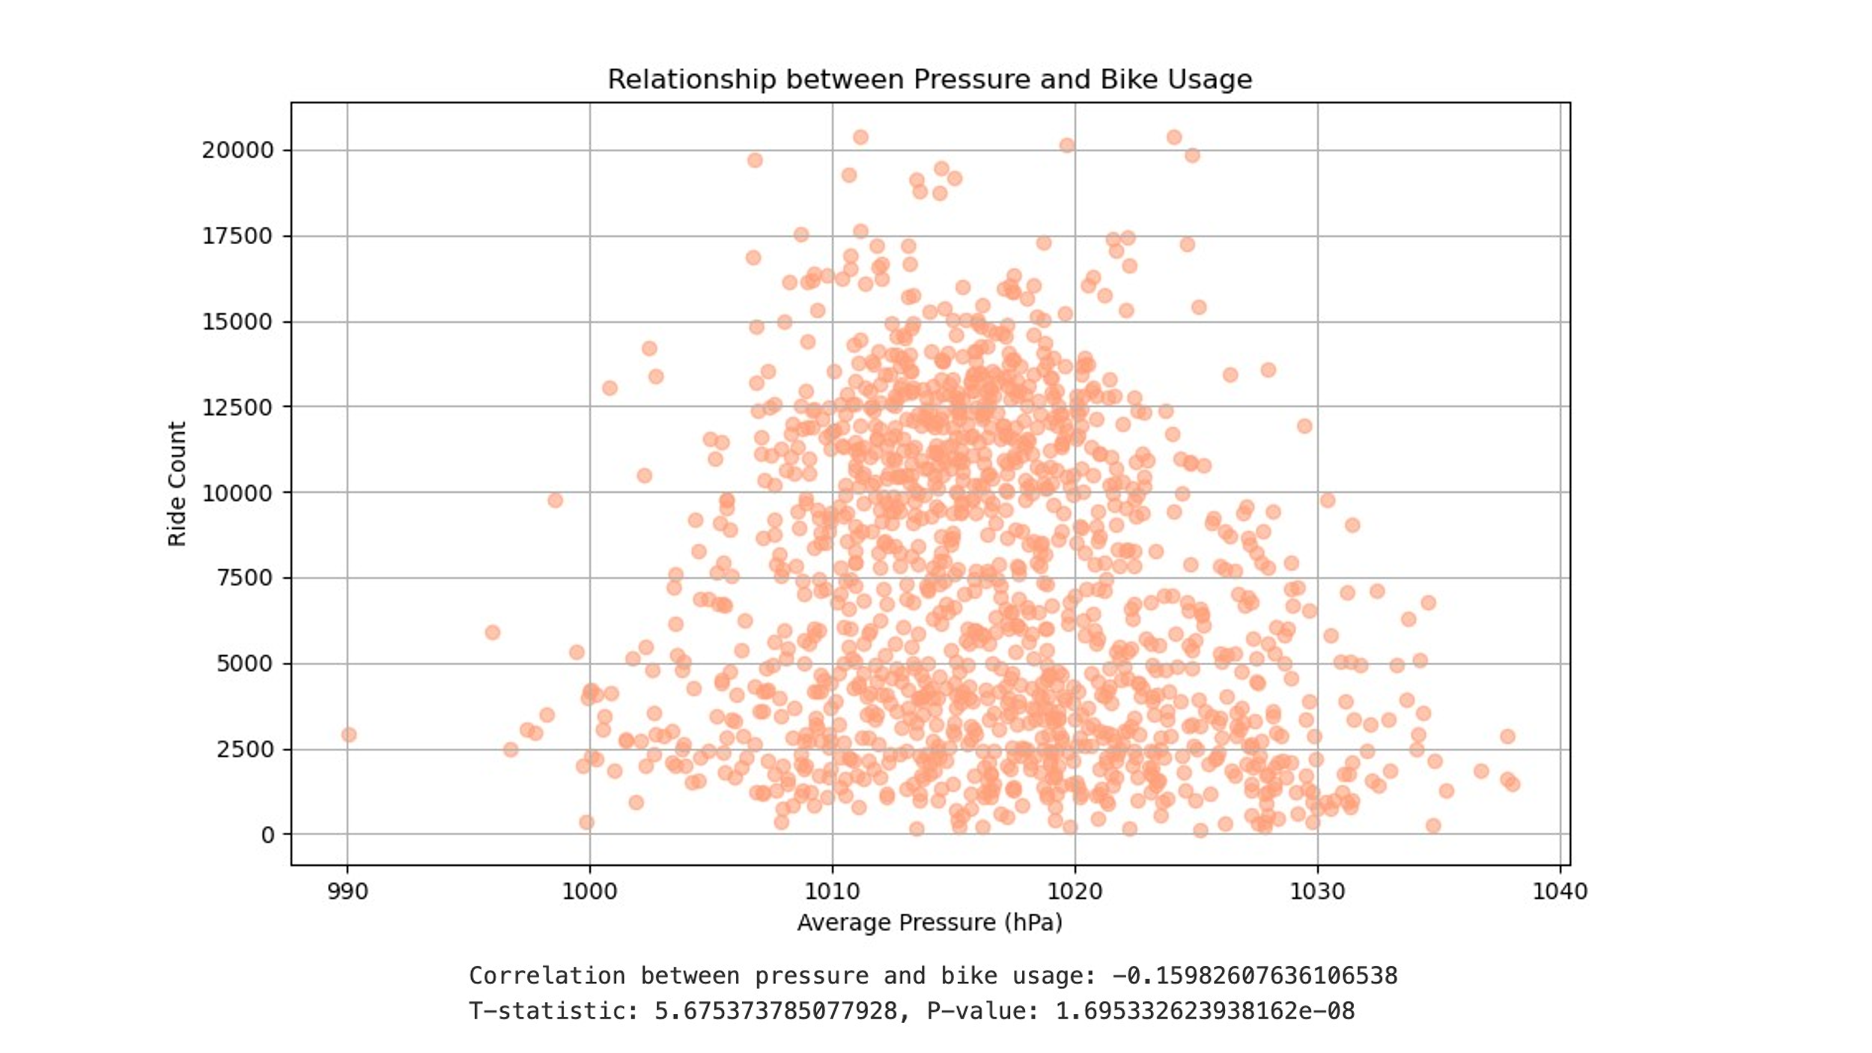

**Analysis-**

* The Pearson correlation coefficient obtained was approximately -0.16, which suggests that there is a weak negative correlation between atmospheric pressure and bike usage. It means as pressure increases, there is a slight tendency for bike usage to decrease. However, the correlation is not strong, so other factors likely contribute significantly to bike usage.

For t test, we define two hypotheses

* 1. Null Hypothesis - There is no significant difference in bike usage between low-pressure and high-pressure days.
  2. Alternative Hypothesis - There is significant difference in bike usage between low-pressure and
* The t-test gives 2 components

1. **t-Statistic (5.67)**: This large t-statistic suggests that the difference in bike usage between the two groups is much greater.
2. **p-Value (1.69e-08)**: The very small p-value provides evidence against null hypothesis, confirming to reject the null hypothesis.
3. **Conclusion:** This indicates that atmospheric pressure (low vs. high) significantly impacts bike usage.
4. **EFFECT OF HUMIDITY ON RIDE USAGE**

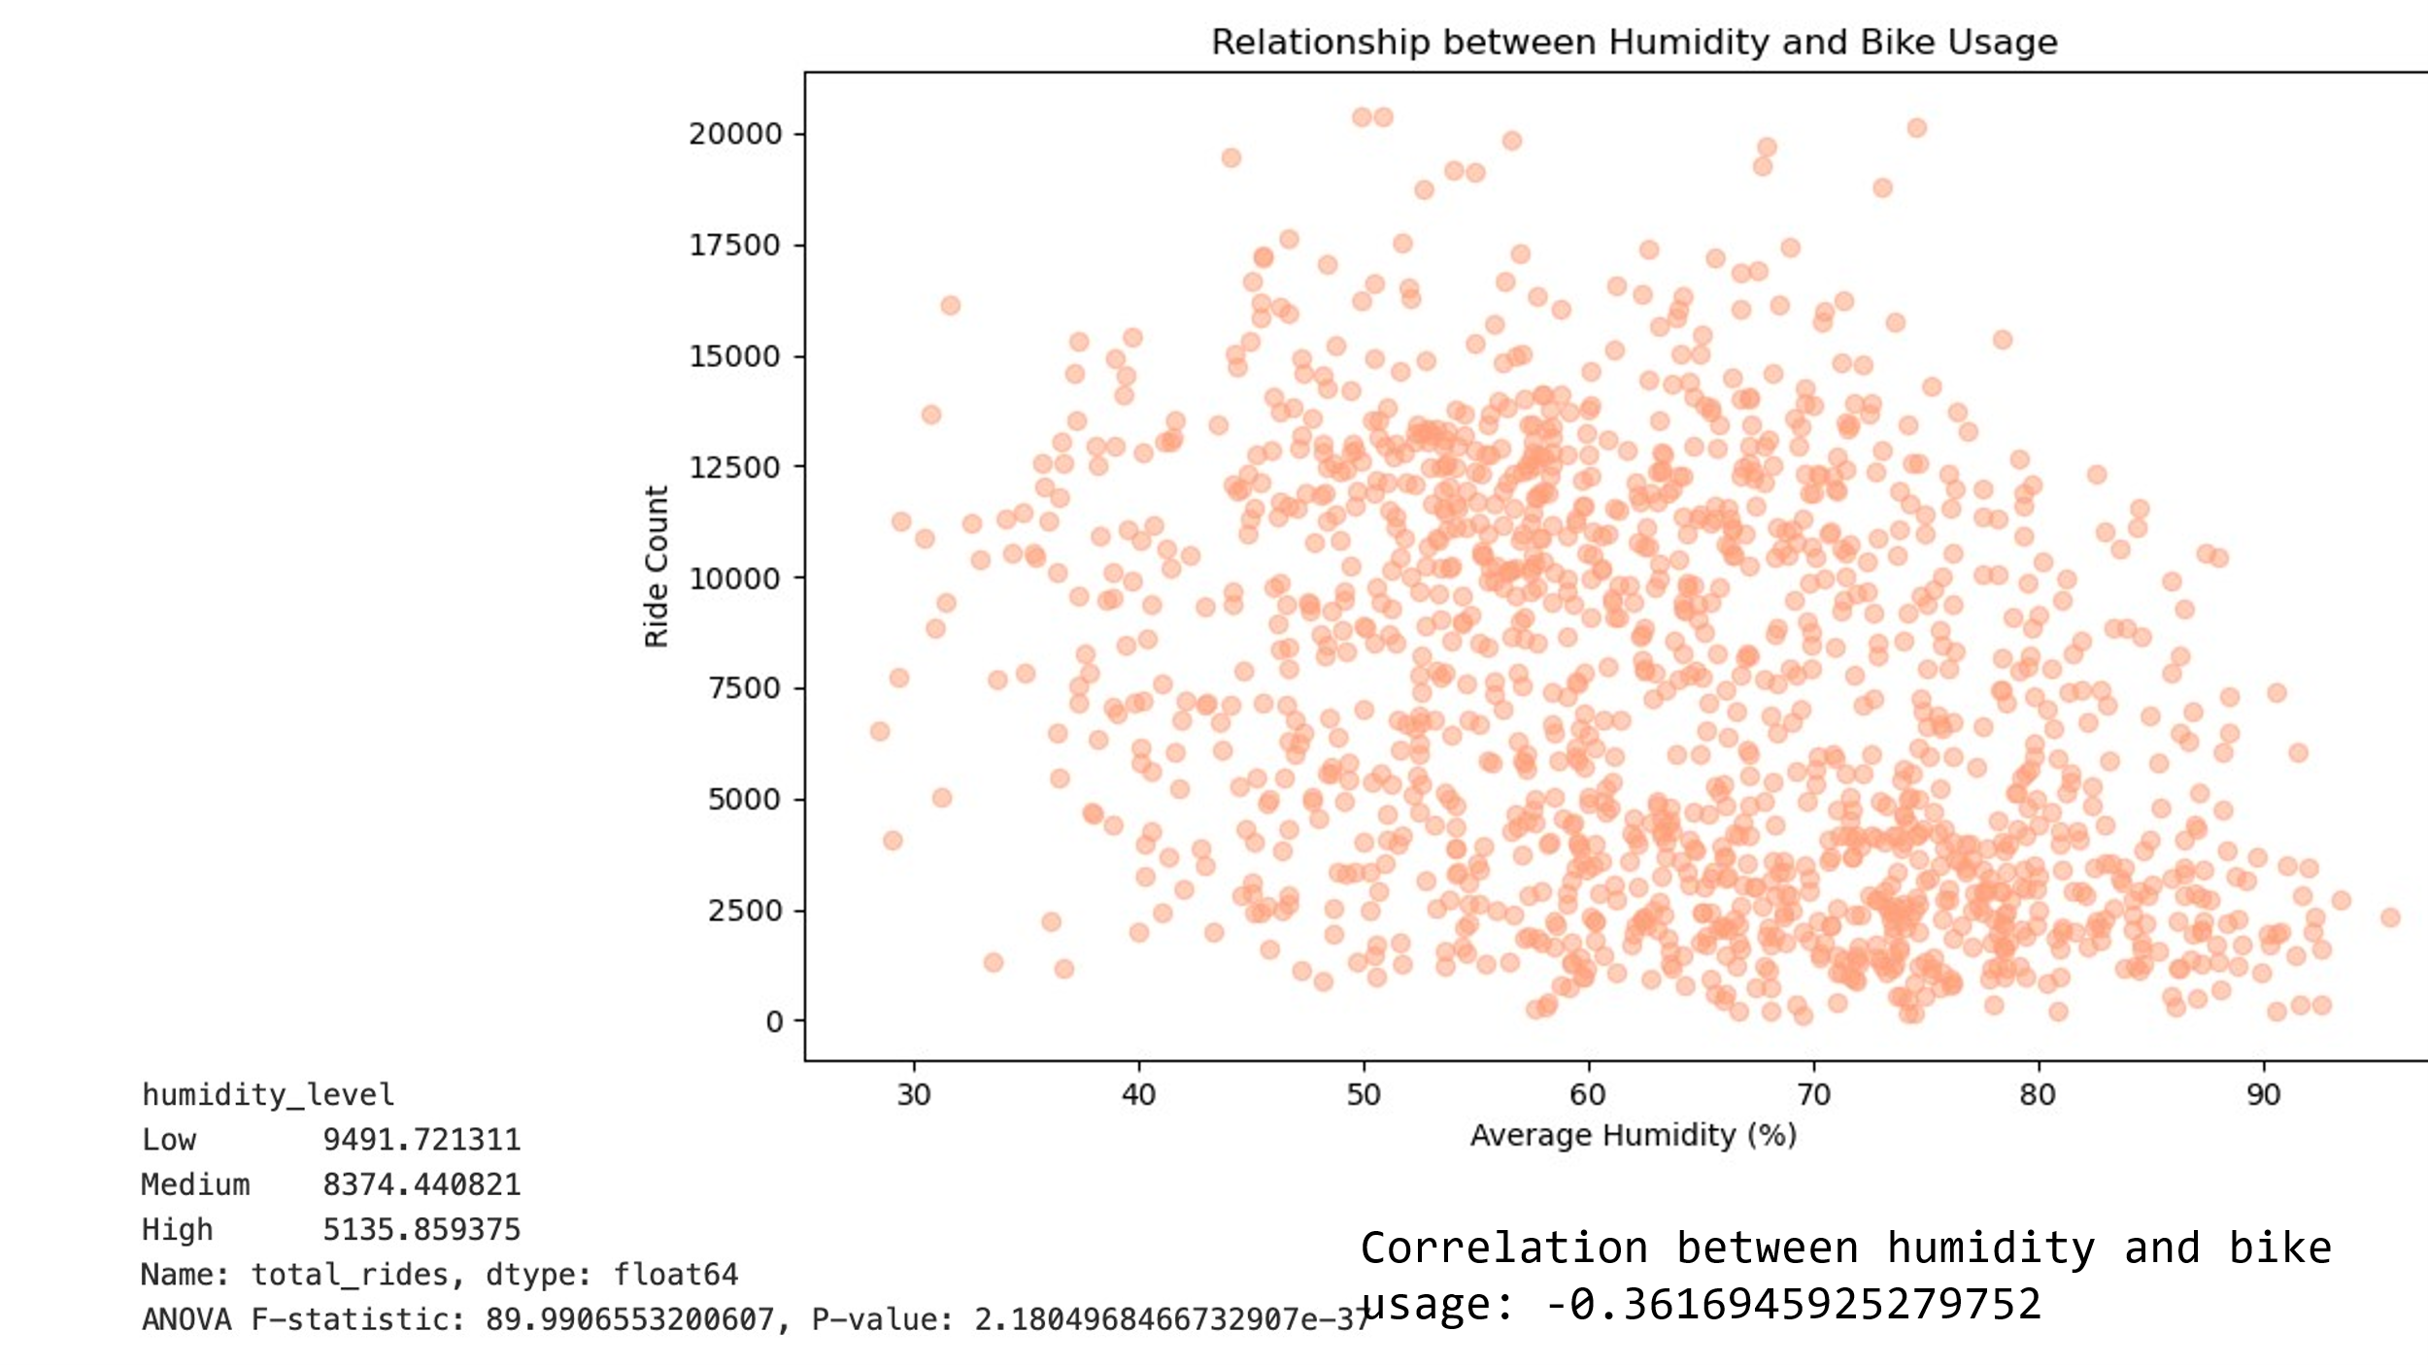

**Analysis-**

The correlation coefficient of -0.36 suggests a moderate negative relationship between humidity and bike usage.

For ANOVA test , we define two hypotheses

* 1.Null Hypothesis: The means of all groups (Low, Medium, High) are equal (no significant difference).
* 2. Alternative Hypothesis - At least one group’s mean is different from the others (there is a significant difference).

**ANOVA test gives two components**

1. **F-statistic**: 89.99 is a **very large F-statistic**, indicating that the variation between the three humidity groups (Low, Medium, and High) is much larger than the variation within each group.
   * A large F-statistic suggests that there is a significant difference between the average number of bike rides across the three humidity levels.
2. **P-value**: 2.18e-37 (which is extremely small)
   * This is an **extremely small p-value**, much smaller than the common significance level of **0.05**.
   * A p-value this small means there is a strong evidence to reject the null hypothesis. In other words, the differences in bike usage between the Low, Medium, and High humidity groups are statistically significant.

**Conclusion:**

* The results suggest that at least one group (Low, Medium, or High humidity) has a significantly different mean bike usage compared to the others. Thus, the null hypothesis is rejected.

1. **EFFECT OF WIND SPEED ON RIDE USAGE**

**Analysis-**

The correlation coefficient of -0.34 suggests a moderate negative relationship between wind speed and bike usage.

We define two hypotheses

* 1.Null Hypothesis: The means of all groups (Low, Medium, High) are equal (no significant difference).
* 2. Alternative Hypothesis - At least one group mean is different from the others (there is a significant difference).

1. **F-statistic**: 65.01
   * This is a **very large F-statistic**, indicating that the variation between the three humidity groups (Low, Medium, and High) is much larger than the variation within each group.
   * A large F-statistic suggests that there is a **significant difference** between the average number of bike rides across the three humidity levels.
2. **P-value**: 1.14e-27 (which is extremely small)
   * This is an extremely small p-value, much smaller than the common significance level of 0.05.
   * A p-value this small means there is strong evidence to reject the null hypothesis. In other words, the differences in bike usage between the Low, Medium, and High humidity groups are statistically significant.

**Conclusion:**

* The results suggest that at least one group (Low, Medium, or High humidity) has a significantly different mean bike usage compared to the others. Thus, the null hypothesis is rejected.

**4.MOST USED RIDEABLE TYPES BY YEAR**

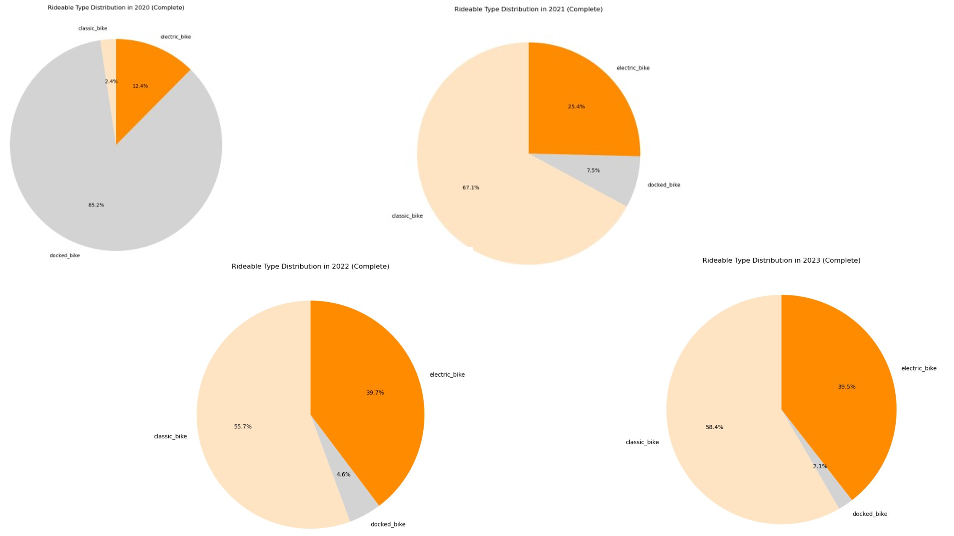

Bike Usage Distribution (2020 - 2023)

The distribution of bike usage over the years reveals significant trends in the popularity of different rideable types:

* **Docked Bikes:**
  + In 2020, docked bikes dominated bike usage, accounting for 85.2% of all rides. However, this percentage has steadily declined over the years, reaching only 2.2% in 2023.
  + This sharp decline suggests a decreasing reliance on traditional docked bikes, which could be attributed to the growing preference for more flexible bike-sharing options like classic and electric bikes.
* **Classic Bikes:**
  + Classic bikes maintained a consistent share over the years. In 2020, they accounted for just 2.4% of rides but saw a substantial increase by 2021, reaching 67%. The share of classic bikes remained relatively stable, hovering around 55-58% in 2022 and 2023.
  + The sharp rise in 2021 could be due to a shift in user preferences toward non-docked bikes, with classic bikes emerging as a popular alternative to docked bikes. Despite fluctuations, classic bikes maintained a substantial presence in the later years.
* **Electric Bikes (E-Bike**s):
  + The most significant growth occurred in the use of electric bikes, which went from 12.4% in 2020 to 39.6% in 2023.
  + This increase highlights a growing trend towards electric bikes as a preferred mode of transportation, likely due to their convenience and appeal for longer distances or ease of use. By 2023, e-bikes accounted for nearly 40% of all rides, showcasing their growing importance in the bike-sharing system.

**Conclusions**

* The decline in docked bikes suggests a shift away from the more traditional bike-sharing model towards flexible options.
* Classic bikes have remained popular, though their market share has stabilized after a major increase in 2021.
* Electric bikes have seen the most significant growth, and their popularity is expected to continue to rise due to their convenience and efficiency, especially in urban areas.

**MOST USED RIDEABLE TYPES BY YEAR AND BY USER TYPE**

**User type = Casual**

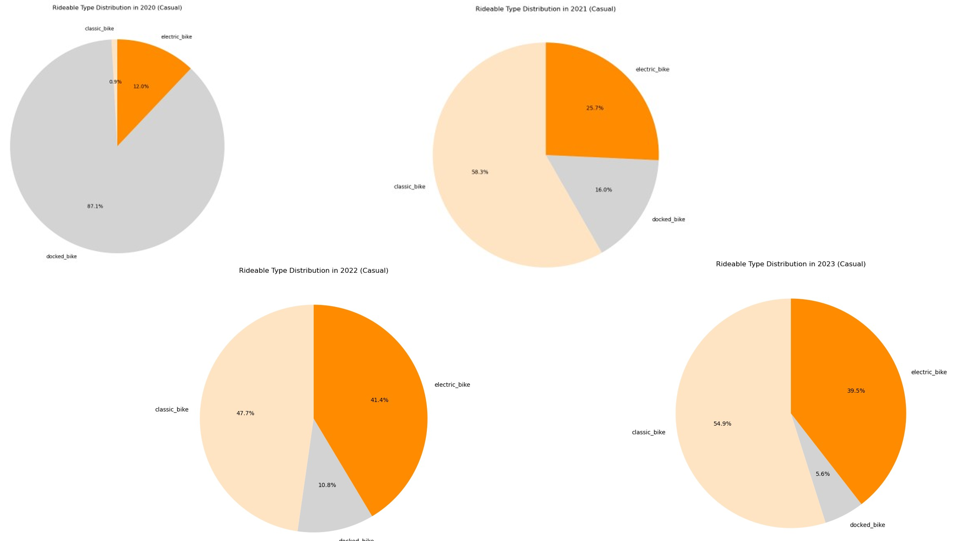

* **Docked Bikes:**
  + 2020: Casual users predominantly relied on docked bikes, which made up 87.1% of all rides.
  + Declining Trend: Over the years, the usage of docked bikes showed a marked decline:
    - In 2021, docked bikes dropped to 16%.
    - By 2022, the percentage further decreased to 10.8%.
    - In 2023, it reached 5.6%.
  + This sharp decline could reflect a shift in user preferences, with casual users increasingly choosing more flexible bike options.
* **Classic Bikes**:
  + 2020: Classic bikes represented only 0.9% of rides, but there was a notable increase starting in 2021.
    - In 2021, classic bikes accounted for 58.3% of rides, showing a significant uptick in usage.
    - This popularity continued in 2022 with 47.7% of rides.
    - In 2023, classic bikes accounted for 54.8%, remaining one of the most popular choices among casual users.
  + The rise in classic bike usage reflects a growing trend towards non-docked bikes, particularly for casual riders who likely prefer a more flexible experience.
* **Electric Bikes (E-Bikes):**
  + 2020: Electric bikes made up 12% of rides, a relatively modest share compared to docked bikes.
  + Growth in Popularity: E-bikes showed consistent growth over the years:
    - In 2021, their share rose to 25.7%.
    - By 2022, it reached 41.4%, becoming increasingly popular among casual users.
    - In 2023, the share stabilized at 39.6%.
  + This steady increase in electric bike usage indicates a shift toward more convenient, easy-to-ride options for casual users, especially for longer distances or those looking for less physical effort.

**Key Insights:**

* Decline of Docked Bikes: Casual users have increasingly abandoned docked bikes in favor of more flexible alternatives. This suggests a broader trend where casual users value convenience and ease of access over the more traditional, docked bike model.
* Rise of Classic Bikes: The rise in classic bike usage, especially after 2020, indicates a growing preference for traditional, non-electric bikes. This could be attributed to the simplicity and familiarity of classic bikes for short, casual trips.
* Surge in Electric Bikes: The most significant trend is the rapid growth in electric bike usage, which increased from 12% in 2020 to around 40% in 2023. E-bikes' appeal likely comes from their ease of use, particularly in urban areas, and their ability to cover longer distances without requiring as much physical effort.

**Conclusion:**

Casual users have shifted from relying on docked bikes to increasingly prefer classic bikes and electric bikes over the past few years. This trend suggests a preference for flexibility and convenience, particularly as electric bikes become a more prominent option. The growth in e-bike usage reflects broader trends in urban mobility and suggests that bike-sharing systems may continue to evolve towards these more user-friendly, flexible models.

**MOST USED RIDEABLE TYPES BY YEAR AND BY USER TYPE**

**User type = Member**

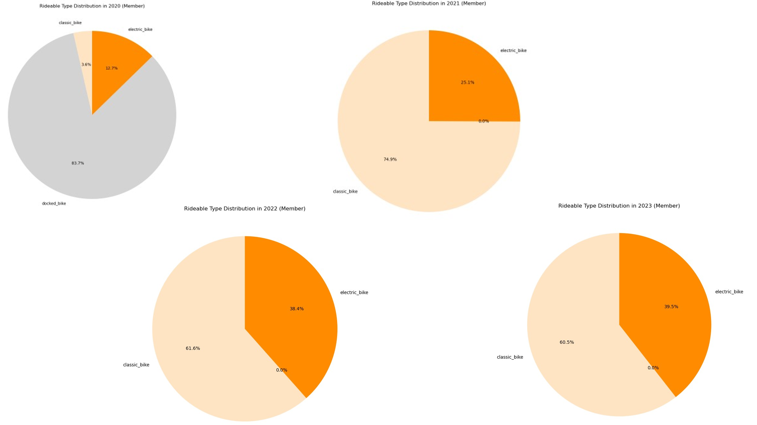

* **Docked Bikes:**
  + 2020: Docked bikes made up 83.7% of the total rides for member users in 2020, indicating a strong preference for traditional bike-sharing models.
  + Decline to 0%: Starting in 2021, docked bikes completely disappeared from the usage data, with 0% of rides. This indicates a sharp shift away from docked bikes among member users.
  + The disappearance of docked bikes suggests that member users have fully transitioned to more flexible bike options (i.e., classic and electric bikes).
* **Classic Bikes:**
  + 2020: Classic bikes were used in only 3.6% of rides.
  + Significant Increase: In 2021, classic bike usage surged to 74.8%, showing a major shift from docked bikes to classic bikes.
  + The percentage of classic bike usage remained high over the following years:
    - 2022: Classic bikes accounted for 61.5%.
    - 2023: They continued to be popular, representing 60.5% of all rides.
  + The steady popularity of classic bikes suggests that member users favored this option once docked bikes were no longer available.
* **Electric Bikes (E-Bikes):**
  + 2020: E-bikes accounted for 12.7% of rides, which is a smaller share compared to classic bikes.
  + Growth in Popularity: From 2021 onwards, the share of e-bikes increased significantly:
    - 2021: E-bike usage grew to 25.2%.
    - 2022: Their share reached 38.5%, showing a noticeable rise in popularity.
    - 2023: E-bikes remained popular, with 39.6% of rides being taken on e-bikes.
  + The increase in e-bike usage reflects the growing appeal of electric bikes, likely due to their convenience, ease of use, and ability to cover longer distances**.**

**Key Insights:**

* Disappearance of Docked Bikes: Unlike casual users, who still used docked bikes to a degree, member users completely stopped using them from 2021 onward. This marks a decisive shift toward more flexible bike-sharing models.
* Classic Bikes: Member users have increasingly relied on classic bikes, especially after the decline of docked bikes in 2021. The high usage of classic bikes suggests that members may value the traditional bike experience for regular, everyday trips.
* Growth of Electric Bikes: Electric bikes have seen a significant increase in popularity among members, rising from 12.7% in 2020 to 39.6% in 2023. This is a clear trend toward more user-friendly, convenient options, especially as e-bikes become more accessible and popular in urban areas.

**Conclusion:**

For member users, the data shows a significant shift from docked bikes to both classic bikes and electric bikes between 2020 and 2023. The disappearance of docked bikes and the increase in e-bike usage indicate that members increasingly prefer flexible, easy-to-use, and faster modes of transportation. The sustained use of classic bikes alongside the rise in e-bike adoption suggests that members value both traditional and modern bike-sharing options, depending on their needs.